1 and 2 Eastbrook Cottages

The History of St Mary’s, Eastbrook Place

St Mary’s at Eastbrook Place forms part of a small but significant historic enclave close to the centre of Dover. The origins of the site are closely connected with the arrival of the Sisters of Charity of Saint Vincent de Paul, a Catholic religious order devoted to charitable and nursing work, who first came to Dover in 1883. At that time the area around Dieu Stone Lane and Maison Dieu Road was developing from a mixture of small cottages and lanes into the more recognisable Victorian streetscape seen today

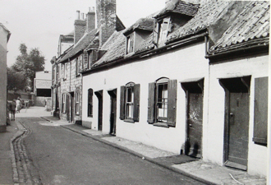oday.

The Sisters initially acquired a number of modest properties in and around Eastbrook Place, gradually adapting them for their charitable activities. These buildings became the centre of a convent community that carried out nursing, teaching and welfare work among the poorer residents of Dover and visiting seafarers. Over the late nineteenth and early twentieth centuries the complex expanded, with additional buildings added to support the work of the Sisters and the institutions they operated on the site, including care for children and later for convalescent women.

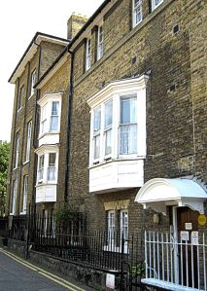

Within the grounds of the convent estate a number of practical service buildings were constructed during the late nineteenth century. Among these was a small utility building used primarily as the convent laundry, where the washing for the house and its residents was undertaken. Such facilities were typical of religious houses of the period, which operated largely as self-contained communities. The laundry building formed part of the working heart of the establishment, supporting the daily life of the convent and its charitable activities.

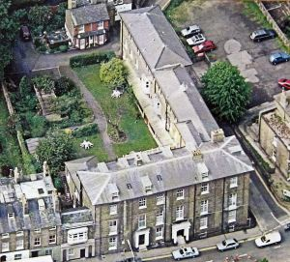

As the role of the convent evolved during the twentieth century, the buildings within the grounds were rebuilt and adapted to changing needs. The former laundry building became accommodation for members of the Sisters’ community, providing residential quarters overlooking the river and close to the main convent house. This adaptation reflected the gradual shift in the use of the site from institutional care and teaching towards residential and community functions.
In more recent years the convent complex has undergone further transformation as its historic buildings have been carefully repurposed. The former service and residential structures within the grounds have now been sensitively converted to create two self-contained cottages, offering visitors the opportunity to stay within this historic setting.
Today these cottages form part of the continuing story of St Mary’s at Eastbrook Place. While their use has changed, the buildings remain closely linked to their Victorian origins and to the long tradition of hospitality and service established on the site by the Sisters of St Vincent more than a century ago.

The Work of the Sisters

For much of the late nineteenth and twentieth centuries the Sisters of Charity of Saint Vincent de Paul played a significant role in the social and charitable life of Dover. Like many houses of the order across Britain and Europe, the community at St Mary’s combined religious life with practical service to the surrounding community, particularly among those facing poverty, illness or hardship.
One of their most important activities was the care and education of children. The Sisters operated facilities on the site that provided accommodation and support for young people who needed protection or assistance, at a time when organised social services were still developing. The children’s home at St Mary’s offered shelter, supervision and schooling, and was part of a wider Catholic charitable network that helped vulnerable children across the region.
The Sisters were also widely involved in nursing and welfare work in Dover. Members of the community frequently visited the sick and elderly in their homes, offering practical assistance as well as companionship. Their work often extended to families connected with the port and maritime industries, where irregular work and economic hardship could place particular strain on households.
In addition to these charitable activities, the convent community helped support local parish life through teaching, pastoral work and practical assistance to nearby churches and schools. The Sisters’ approach reflected the ethos of the Vincentian tradition, which emphasises service to those most in need through simple, practical acts of care.
Although the role of religious communities in social care has gradually changed over time, the legacy of the Sisters’ work remains an important part of the history of St Mary’s. And while their purpose of the cottages here has evolved, they remain part of the long story of St Mary’s, a place that for more than a century has offered hospitality, care and refuge within the heart of Dover.

